Posting of Temporary Signs

The City seeks to balance the interests of aesthetics and public safety with the ability of candidates to place temporary campaign signs in the public right-of-way. The Development Code of the City allows each candidate to place signs in the right-of-way subject to limitations on the time, manner and placement of those signs. These instructions are intended to provide clear instruction for candidates and staff regarding the election of November 8, 2022.

The regulations described here will take effect in the City of Rancho Cucamonga on August 17, 2018.

All candidates and campaign staff are advised to take note of City sign ordinances and to contact the City of Rancho Cucamonga for further information prior to posting signs, either in the right-of-way or on private property, for the November election.

City Right-of-Way

- Signs must be free standing and not affixed to any City structure, including street signs, utility poles, signal poles, etc.
- Do not post in a manner to obstruct any permanent, permitted sign.
- The maximum size for signs in the right-of-way is nine square feet in area and 36 inches in height measured from the ground.
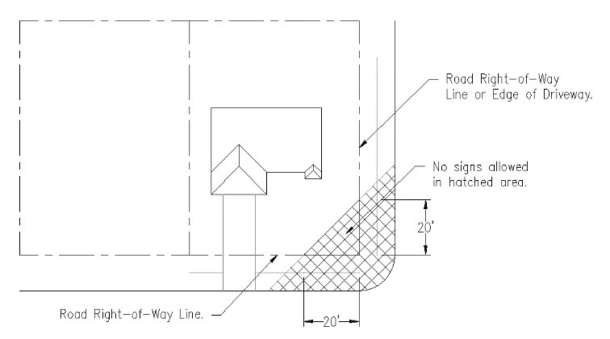
- Signs shall not be placed in a manner to create a traffic or pedestrian hazard. Any sign placed in a traffic median or the “clear visibility triangle” at any street intersection shall be considered a traffic hazard.
Clear Visibility Triangle Diagram
- No signs are permitted in or adjacent to any City facilities, including parks, libraries, public buildings or unimproved parcels owned by the City.
- Only one sign with two display faces is permitted on each side of the street within any City block.
- Signs may be displayed continuously for two periods of up to 60 days each within a single calendar year. A minimum of 60 days shall separate each period. Campaign signs must be removed promptly, but in no case more than 48 hours, after election day. For the election scheduled for November 8, 2022, the first day for display of campaign signs in the right-of-way is September 9, 2022, allowing for removal within two days following the election.
- Signs which have become worn, dilapidated, or damaged shall be removed.

Private Property

Temporary signs on private property are generally permitted for non-commercial speech, such as campaign signs. On commercial property, such signs shall not exceed 32 square feet, have a maximum height of eight feet and shall be set back five feet from the right-of-way. Signs at residential properties are limited to six square feet in area, maximum height of eight feet, shall not project above a roofline, and shall be set back five feet from the right-of-way.

It is highly recommended that permission from a property owner be obtained prior to posting signs on private property. Property owners may remove signs from their own property when posted without consent.

Restrictions relating to safety remain in effect, such as the Clear Visibility Triangle as diagramed above. Any signs placed on private property but extending to the right-of-way creating a hazard may still be removed to preserve public safety.

Procedures

City staff may remove without notice any signs posted in the right-of-way when in violation of City ordinances. Photographs will be taken of the signs in place to demonstrate any violation. Signs will be taken to the Corporate Yard and stored for 30 days for retrieval by a responsible party.

Those responsible for placement of signs may contact the Community Improvement Division at 909-774-2712 to provide telephone and address contact information. City staff will make reasonable effort to contact a responsible party to allow any potential violations to be corrected, allowing the responsible person time to resolve any problems prior to the City taking action.

All stored signs may be retrieved form the Corporation Yard at 8794 Lion St., Monday through Thursday, 7:00 am to 5:30 pm.

